
AMERICAN INTERNATIONAL UNIVERSITY-BANGLADESH
Faculty of Science and Technology
Department of Computer Science
CSC 4118: Computer Graphics

Final Term Project Evaluation | Semester: Spring 2024-2025 |  | CO Assessed: CO3 |  |  | Total Marks:
Name |  | ID |  | Section: | SL. | Group No.
Fahim Hassan |  | ID: 23-55325-3 |  |  |  | 5
AIQUL ISLAM SAKIB |  | ID: 23-55255-3 |  |  |  | 5
MD. NAFIS-UL HOQUE BONDHON |  | ID: 23-55212-3 |  |  |  | 5
Fabiha Lamisa Tridha |  | ID: 23-54966-3 |  |  |  | 5
OBE Evaluation:
CO3: Integrate the development of visual and conceptual skills to design solutions through the process of idea development, refinement, and assessment in the creation of real-world projects.
Requirement specification (5) | Design & Implementation (5) | Total Marks (10)

City Of Disaster


AMERICAN INTERNATIONAL UNIVERSITY-BANGLADESH
Faculty of Science and Technology
Department of Computer Science
CSC 4118: Computer Graphics

Final Term Project Evaluation | Semester: Spring 2024-2025 |  | CO Assessed: CO3 |  |  | Total Marks:
Name: |  | ID: |  | Section: | SL. | Group No.
OBE Evaluation:
CO3: Integrate the development of visual and conceptual skills to design solutions through the process of idea development, refinement, and assessment in the creation of real-world projects.
Requirement specification (5) | Design & Implementation (5) | Total Marks (10)

Building 1 (Left)  A = (1.0, 1.0)  B = (1.0, 9.0)  C = (6.0, 9.0)  D = (6.0, 1.0)  A1 = (1.0, 9.0)  B1 = (1.0, 9.35)  C1 = (6.0, 9.35)  D1 = (6.0, 9.0)  A2 = (2.8, 1.0)  B2 = (2.8, 2.4)  C2 = (4.2, 2.4)  D2 = (4.2, 1.0)  W11 = (2.0, 7.2)  W12 = (2.0, 8.2)  W13 = (3.0, 8.2)  W14 = (3.0, 7.2)  W21 = (4.0, 7.2)  W22 = (4.0, 8.2)  W23 = (5.0, 8.2)  W24 = (5.0, 7.2)  W31 = (2.0, 5.2)  W32 = (2.0, 6.2)  W33 = (3.0, 6.2)  W34 = (3.0, 5.2)  W41 = (4.0, 5.2)  W42 = (4.0, 6.2)  W43 = (5.0, 6.2)  W44 = (5.0, 5.2)  W51 = (2.0, 3.2)  W52 = (2.0, 4.2)  W53 = (3.0, 4.2)  W54 = (3.0, 3.2)  W61 = (4.0, 3.2)  W62 = (4.0, 4.2)  W63 = (5.0, 4.2)  W64 = (5.0, 3.2)  Building 3 (Right) (36 points)  ----------------------------  I = (15.0, 1.0)  J = (15.0, 9.0)  K = (20.0, 9.0)  L = (20.0, 1.0)  I1 = (15.0, 9.0)  J1 = (15.0, 9.35)  K1 = (20.0, 9.35)  L1 = (20.0, 9.0)  I2 = (16.8, 1.0)  J2 = (16.8, 2.4)  K2 = (18.2, 2.4)  L2 = (18.2, 1.0)  R11 = (16.0, 7.2)  R12 = (16.0, 8.2)  R13 = (17.0, 8.2)  R14 = (17.0, 7.2)  R21 = (18.0, 7.2)  R22 = (18.0, 8.2)  R23 = (19.0, 8.2)  R24 = (19.0, 7.2)  AL = (1.2, -0.2)  BL = (1.0954, -0.27504)  CL = (1.4, -0.2)  DL = (1.39433, -0.26383)  ALL = (5.0733, -0.04348)  BLL = (4.98032, -0.04348)  CLL = (5.081382038564059, -0.2011386573787951)  DLL = (5.2, -0.2)  Building Fire  -----------------------  BF1 = (9.05, 6.02)  BF2 = (9.14, 6.44)  BF3 = (9.24, 6.2)  BF4 = (9.36, 6.82)  BF5 = (9.48, 6.34)  BF6 = (9.595032202873078, 7.2321714168070255)  BF7 = (9.72, 6.4)  BF8 = (9.832103816218803, 6.9104313701235265)  BF9 = (9.95, 6.18)  BF10 = (9.98, 6.02)  Fire Truck  --------------------  FA = (10.0, -1.0)  FB = (9.8, -2.0)  FC = (9.8, -2.8)  FD = (12.0, -1.0)  FE = (12.0, -2.8)  FF = (11.06741, -1.25867)  FG = (11.664331080533787, -1.2627080053245352)  FH = (11.07547, -1.96046)  FI = (11.67643, -1.95643)  FJ = (10.15589, -1.20624)  FK = (10.0, -2.0)  FL = (10.81331, -1.95643)  FM = (10.8, -1.2)  RA = (15.98964, -1.20576)  RB = (16.00119, -2.78821)  TyreA = (10.926243111095005, -2.803416225683128)  TyreB = (14.199488515425385, -2.7935189357174077)  TyreC = (15.19264, -2.76511)  EqpDoorA = (12.29339, -1.30971)  EqpDoorB = (12.90558, -1.32127)  EqpDoorC = (12.292382482794487, -2.5854182986699272)  EqpDoorD = (12.904542380118228, -2.598512628024446)  CyrenE = (10.70478, -0.79873)  CyrenF = (10.65662, -0.95588)  CyrenG = (11.13313, -0.79873)  CyrenH = (11.16608, -0.95841)  CyrenI = (10.92276, -0.75311)  CyrenJ = (10.654089812966168, -1.0)  G_2 = (7.999996058465015, -1.9160127240184097)  G_3 = (12.161515754042998, 4.607791641275242)  H_1 = (11.4, 1.4)  H_2 = (8.834089712780441, -1.9802613911330116)  H_3 = (11.746236093114462, 4.208940423428214)  I_1 = (11.551416742408305, 1.4004194305825275)  I_2 = (8.809569100052462, -2.0429251792156293)  I_3 = (10.8, 4.6)  J_1 = (11.57738469758632, 1.039753386443429)  J_2 = (8.437862234193563, -1.8943664744966286)  J_3 = (11.240447182121029, 4.202785622126557)  K_1 = (11.637976593001687, 1.042638714796542)  K_2 = (18.0, -1.78)  L_1 = (11.97267468196276, 2.064044951798469)  L_2 = (17.673928528217203, -1.881974374803727)  M_1 = (11.975560010315872, 2.0294210115611153)  M_2 = (17.677143334418705, -2.998263010810807)  N_1 = (11.649477300207385, 1.7120337488818986)  N_2 = (17.8, -3.0)  O_1 = (10.91664450472351, 1.9774851012050851)  O_2 = (17.847170307624264, -2.5016052732892917)  P_1 = (10.899332534604834, 1.939975832614619)  P_2 = (18.111159555496055, -2.497130879257566)  Q_1 = (11.275734609649968, 1.7091681372612055)  Q_2 = (18.2, -3.0)  R_1 = (8.220513465464, -1.697893919714499)  R_2 = (18.31698168095542, -2.998263010810807)  S_1 = (8.0, -1.8)  S_2 = (18.302836991491088, -1.8950222682326459)  T_1 = (8.433185219108827, -1.7852361225194677)  T_2 = (18.75994669009622, -2.2868343597664738)  U_1 = (8.449532294260814, -2.1666678760658424)  U_2 = (18.717760002530703, -2.3595272743021605) | R31 = (16.0, 5.2)  R32 = (16.0, 6.2)  R33 = (17.0, 6.2)  R34 = (17.0, 5.2)  R41 = (18.0, 5.2)  R42 = (18.0, 6.2)  R43 = (19.0, 6.2)  R44 = (19.0, 5.2)  R51 = (16.0, 3.2)  R52 = (16.0, 4.2)  R53 = (17.0, 4.2)  R54 = (17.0, 3.2)  R61 = (18.0, 3.2)  R62 = (18.0, 4.2)  R63 = (19.0, 4.2)  R64 = (19.0, 3.2)  Tree  --------------------  TG1 = (-1.6, 0.7)  TG2 = (-1.6, 1.1)  TG3 = (0.2, 1.1)  TG4 = (0.2, 0.7)  TT1 = (-0.82, 1.1)  TT2 = (-0.9137608221974441, 2.8596935178234495)  TT3 = (-0.68, 3.35)  TT4 = (-0.53, 4.0)  TT5 = (nan, nan)  TT6 = (-0.33, 3.0)  TT7 = (-0.18, 3.55)  TT8 = (0.02, 4.05)  TT9 = (0.18, 3.35)  TT10 = (0.04, 2.8)  TT11 = (0.04, 1.1)  TT12 = (-0.32, 1.1)  TC1 = (-2.2260959367896445, 4.047655436442419)  TC2 = (-2.40047043997214, 4.4711363727427695)  TC3 = (-2.288372545069107, 4.969349238978476)  TC4 = (-2.0766320769189344, 5.343008888655256)  TC5 = (-1.7901596788334064, 5.729123859987929)  TC6 = (-1.2456593964308065, 5.893294989410997)  TC7 = (-0.48378353851678596, 6.165321814730904)  TC8 = (0.0, 6.0)  TC9 = (0.6227144439817736, 5.853783547813831)  TC10 = (1.0953931937869834, 5.552987979755968)  TC11 = (1.320989869830379, 5.316648604853361)  TC12 = (1.28, 4.9)  TC13 = (1.3696708691491442, 4.4088117211788775)  CyrenK = (11.171148261193883, -1.0)  MoiA = (11.6497, -0.75443)  MoiA1 = (12.16326636479759, -0.3835461873006759)  MoiB = (11.65513, -0.8684)  MoiB1 = (12.12798442121101, -0.7855282682579428)  MoiC = (15.81789, -1.13434)  MoiC1 = (12.218457026288025, -0.5071931682412929)  MoiD = (15.82331, -1.0258)  MoiD1 = (12.2, -0.88704)  MoiE = (11.65513, -0.35281)  MoiE1 = (12.7007920938044, -0.41606008048024956)  MoiF = (11.66055, -0.47764)  MoiF1 = (12.769265414350341, -0.5363703110161847)  MoiG = (15.87216, -0.60789)  MoiG1 = (12.71074751819723, -0.8234197870220703)  MoiH = (15.8613, -0.70016)  MoiH1 = (12.79318, -0.92146)  MoiI1 = (13.251191008864112, -0.44935264782111056)  MoiJ1 = (13.343234940056627, -0.5678793686521162)  MoiK1 = (13.237907174095263, -0.8576959450294186)  MoiL1 = (13.346340767938246, -0.9764438438981582)  MoiM1 = (13.789195526774108, -0.48189550201671316)  MoiN1 = (13.881305186010874, -0.5952767182029731)  MoiO1 = (13.756641513453067, -0.8914242851645839)  MoiP1 = (13.846824696350746, -1.008417509428244)  MoiQ1 = (14.33431749037181, -0.5148688767554515)  MoiR1 = (14.45615981618501, -0.6257276263280339)  MoiS1 = (14.339349231121478, -0.9293122031405512)  MoiT1 = (14.461389293432385, -1.04767927540752)  MoiU1 = (14.988255344145024, -0.5544243145257475)  MoiV1 = (15.073405842804029, -0.6584240700210088)  MoiW1 = (14.96246895448547, -0.9698277279091057)  MoiZ1 = (15.083529007828242, -1.087424981536731)  V_1 = (7.999987727581173, -2.16121885101518)  V_2 = (18.305614794483827, -2.1116820573482116)  W_1 = (8.0, -2.6)  W_2 = (17.196375628718776, -2.24209623344189)  Z_1 = (8.081723103341108, -2.5971408550681794)  Z_2 = (17.24856720243445, -2.307335700586485)  A_1 = (10.086371, -1.988463)  B_1 = (11.013609, -3.743235)  C_1 = (12.868084, -4.132077)  D_1 = (14.363629, -4.171958)  E_1 = (16.218104, -3.892790)  F_1 = (17.374658, -1.998433)  T_1 = (14.951876, -2.257661)  S_1 = (13.516153, -2.267631)  Q_1 = (11.970757, -2.227750) | TC14 = (1.1478966851384687, 3.7434891691468457)  TC15 = (0.4723166599528431, 2.8780559638128254)  TC16 = (-0.5267543339536231, 2.598745793473381)  TC17 = (-1.6654804130298106, 3.114395338715432)  TC18 = (-2.019989475383718, 3.5226178953653897)  M = (-1.1820589643653914, 3.801928065704834)  N = (-1.1347159090538896, 4.007991504662624)  O = (-0.6282448166678567, 3.558425249031473)  P = (-0.7516974019579005, 2.2253309871715103)  Q = (-0.09178277580886131, 2.1952425866158527)  R = (-0.7667260852913377, 1.6962058777027136)  S = (-0.0756662617422665, 1.695630650551405)  Red Car  --------------------  CA1 = (0.992592835871545, -0.6018507829860655)  CA2 = (1.0, -0.25)  CA3 = (1.25, 0.0)  CA4 = (1.75, 0.2)  CA5 = (2.402458497443733, 0.21570445271853353)  CA6 = (2.9363721207610114, 0.5410580669275067)  CA7 = (4.15, 0.55)  CA8 = (4.6, 0.2)  CA9 = (5.0, 0.08)  CA10 = (5.3, -0.2)  CA11 = (5.297271423867102, -0.5768235818930676)  A11 = (1.790571086337348, -0.6024061755318681)  B11 = (4.406276161287353, -0.5584447457007747)  A112 = (5.080351418697439, 0.0)  AAA = (3.07819, 0.18233)  BBB = (3.3951632751722256, 0.4526681404143728)  CCC = (4.11652, 0.45399)  DDD = (4.32955, 0.19068)  EEE = (3.255952080707099, 0.18157265645596368)  V = (2.950555121745394, 0.46898036680558575)  W = (2.4589902590720056, 0.17823773461461204)  Z = (3.2922526482378713, 0.47197771352920403)  Flying Objects / Storm Extras  ---------------------------------------  LF1 = (9.08, 6.02)  LF2 = (9.18, 6.34)  LF3 = (9.28, 6.18)  LF4 = (9.4, 6.58)  LF5 = (9.52, 6.24)  LF6 = (9.64, 6.72)  LF7 = (9.76, 6.3)  LF8 = (9.88, 6.52)  LF9 = (9.92, 6.02)  LI1 = (9.24, 6.06)  LI2 = (9.34, 6.28)  LI3 = (9.44, 6.16)  LI4 = (9.56, 6.46)  Human / Extra Action Points  -------------------------------------  HumanR1 = (8.231571292234321, -1.5182338950370056)  HeadB3 = (11.48776, 4.57318)  HeadK2 = (18.0, -1.6)  A_1 = (11.456271071282936, 1.990122942030558)  A_2 = (8.122590791221075, -2.1993620263698173)  A_3 = (17.674507183030645, -2.082902751796692)  B_1 = (11.274425220509485, 1.801480071665205)  B_2 = (8.310582155468925, -2.1993620263698173)  B_3 = (11.494595488294568, 4.393309835437405)  C_1 = (11.646632578061025, 1.8130213850776562)  C_2 = (8.359623380924885, -2.591691830017517)  C_3 = (11.22241795429906, 4.3101414787028345)  D_1 = (11.658173891473476, 1.4033047589356402)  D_2 = (8.446807781735483, -2.591691830017517)  D_3 = (11.76234150501179, 4.321678306709518)  E_1 = (11.28019587721571, 1.394648773876302)  E_2 = (7.692117812218752, -2.084932500305905)  E_3 = (11.718501558586398, 4.014798681731764)  F_1 = (11.31193448909995, 1.0339827297372035)  F_2 = (7.719362937472064, -2.1421472633378613)  F_3 = (11.27317999752846, 4.007876584927755)  G_1 = (11.37541171286843, 1.0368680580903162)  G_1 = (10.901019, -2.778139)  H_1 = (11.399293, -2.979568)  I_1 = (12.003582, -3.202201)  R_1 = (12.563710, -3.325191)  L_1 = (13.360582, -3.382428)  M_1 = (14.176902, -3.393029)  N_1 = (15.209411, -3.401509)  O_1 = (16.031953, -3.096236)  P_1 = (16.557701, -2.757044)

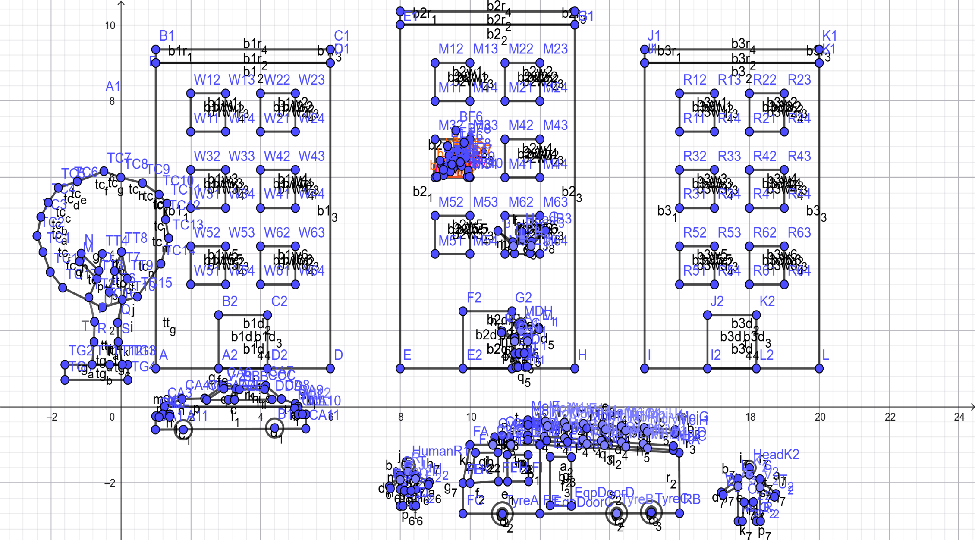
Fahim Hassan (ID:23-55325-3)
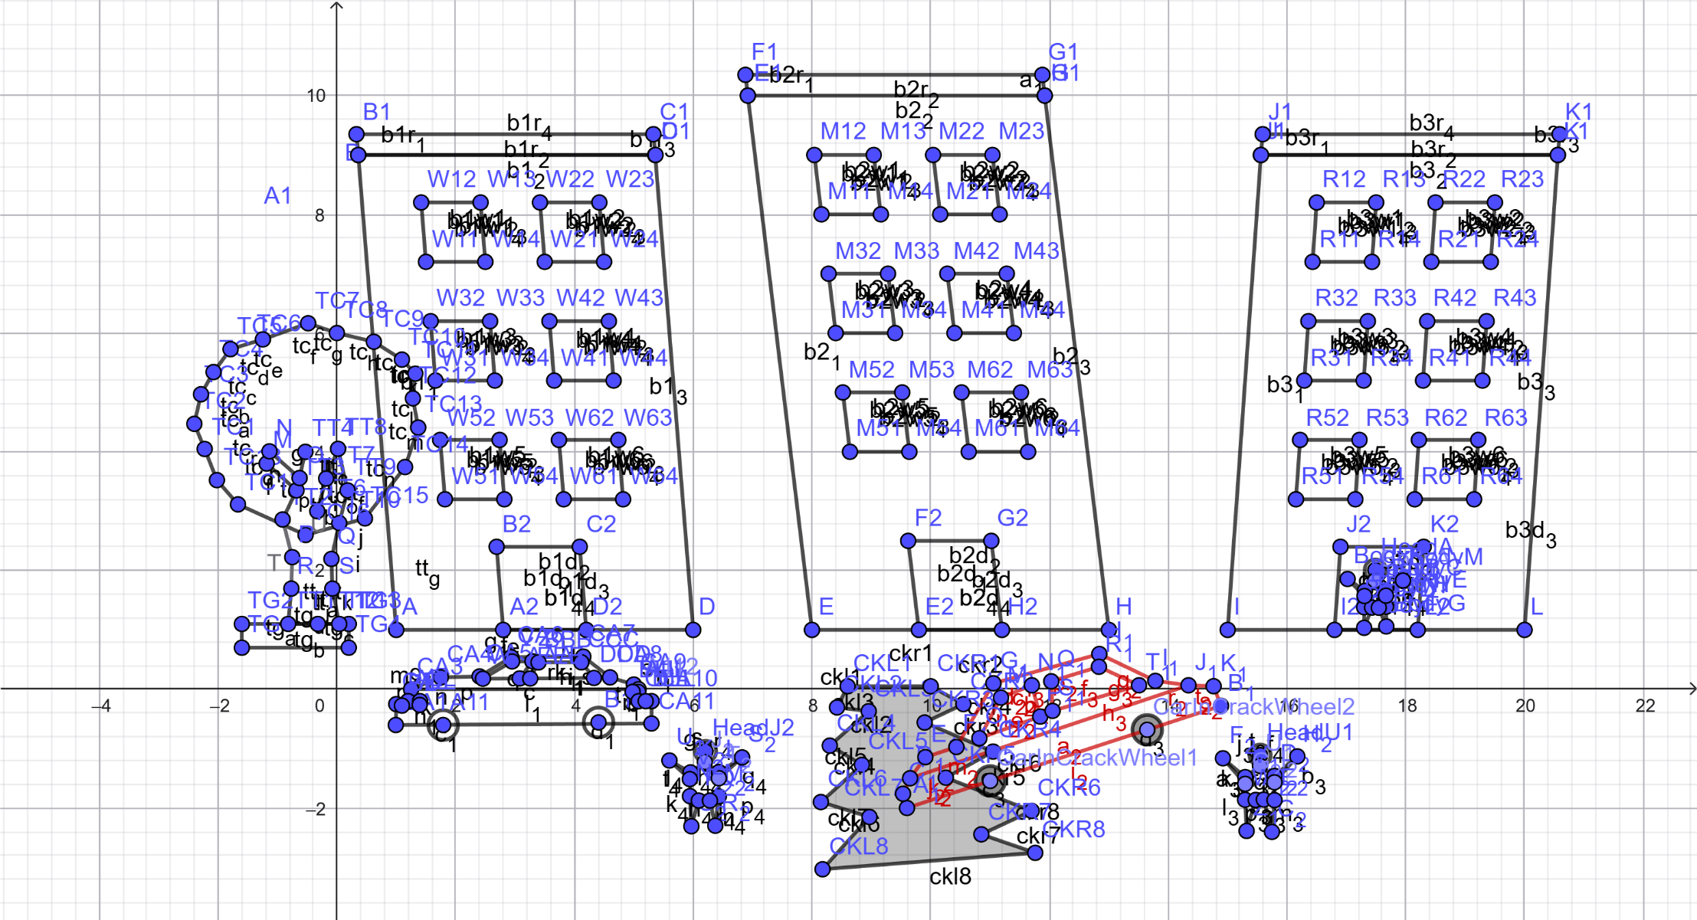
AIQUL ISLAM SAKIB (ID: 23-55255-3)

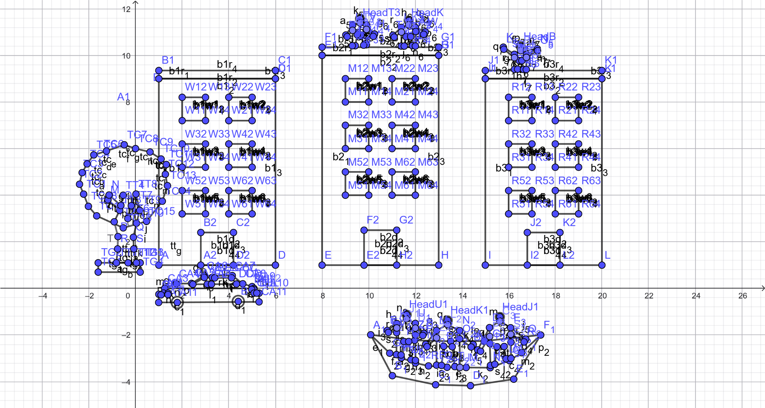
Fabiha Lamisa Tridha (ID: 23-54966-3)
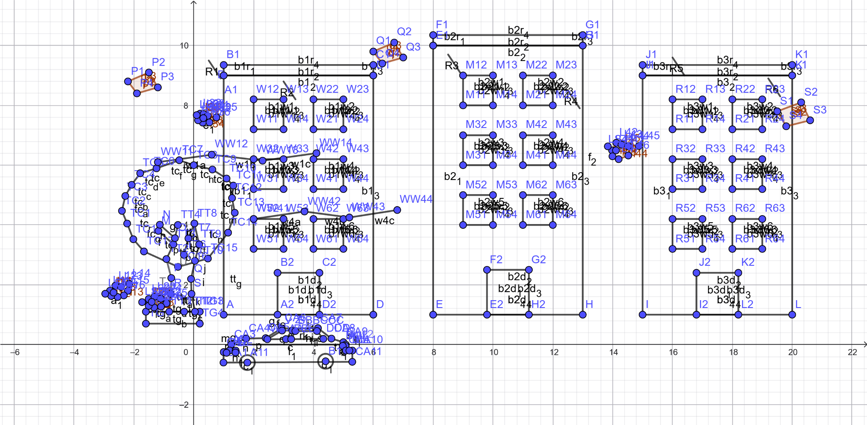
MD. NAFIS-UL HOQUE BONDHON (ID: 23-55212-3)

